**Exercise 1: Logging Error Messages and Warning Levels**

**Task:** Write a Java application that demonstrates logging error messages and warning levels using SLF4J.

**Step 1**:Add SLF4J and Logback Dependencies

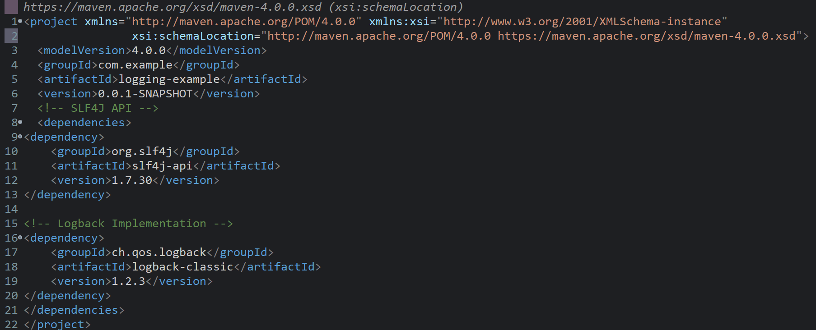

**Step 2:**Add Logging Code

**File Name:** LoggingExample.java

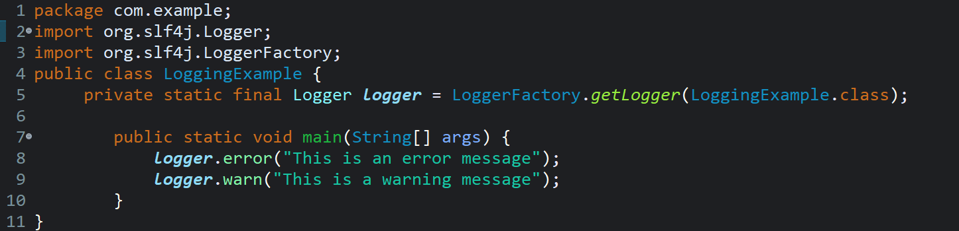

Output:

